RESTful Web Services Tutorial

RESTful Web Services are REST architecture based web services. In REST Architecture everything is a resource. RESTful web services are light weight, highly scalable and maintainable and are very commonly used to create APIs for web based applications.

RESTful Web Services - Introduction

What is REST ?
REST stands for REpresentational State Transfer. REST is web standards based architecture and uses HTTP Protocol for data communication. It revolves around resource where every component is a resource and a resource is accessed by a common interface using HTTP standard methods. REST was first introduced by Roy Fielding in 2000.
In REST architecture, a REST Server simply provides access to resources and REST client accesses and presents the resources. Here each resource is identified by URIs/ global IDs. REST uses various representations to represent a resource like text, JSON and XML. Now a days JSON is the most popular format being used in web services.

HTTP Methods
Following well known HTTP methods are commonly used in REST based architecture.
- GET - Provides a read only access to a resource.
- PUT - Used to create a new resource.
- DELETE - Used to remove a resource.
- POST - Used to update a existing resource or create a new resource.
- OPTIONS - Used to get the supported operations on a resource.

RESTFul Web Services
A web service is a collection of open protocols and standards used for exchanging data between applications or systems. Software applications written in various programming languages and running on various platforms can use web services to exchange data over computer networks like the Internet in a manner similar to inter-process communication on a single computer. This interoperability (e.g., between Java and Python, or Windows and Linux applications) is due to the use of open standards.
Web services based on REST Architecture are known as RESTful web services. These web services use HTTP methods to implement the concept of REST architecture. A RESTful web service usually defines a URI, Uniform Resource Identifier a service, provides resource representation such as JSON and set of HTTP Methods.

Creating RESTFul Web Service
This tutorial will create a web service say user management with following functionalities:
Sr. No. | HTTP Method | URI | Operation | Operation Type
1 | GET | /UserService/users | Get list of users | Read Only
2 | GET | /UserService/users/1 | Get User with Id 1 | Read Only
3 | PUT | /UserService/users/2 | Insert User with Id 2 | Idempotent
4 | POST | /UserService/users/2 | Update User with Id 2 | N/A
5 | DELETE | /UserService/users/1 | Delete User with Id 1 | Idempotent
6 | OPTIONS | /UserService/users | List the supported operations in web service | Read Only

RESTful Web Services - Environment Setup

This tutorial will guide you on how to prepare a development environment to start your work with Jersey Framework to create RESTful Web Services. Jersey framework implements JAX-RS 2.0 API, which is standard specification to create RESTful web services. This tutorial will also teach you how to setup JDK, Tomcat and Eclipse on your machine before you setup Jersey Framework:

Step 1 - Setup Java Development Kit (JDK):
You can download the latest version of SDK from Oracle's Java site: Java SE Downloads. You will find instructions for installing JDK in downloaded files, follow the given instructions to install and configure the setup. Finally set PATH and JAVA_HOME environment variables to refer to the directory that contains java and javac, typically java_install_dir/bin and java_install_dir respectively.
If you are running Windows and installed the JDK in C:\jdk1.7.0_75, you would have to put the following line in your C:\autoexec.bat file.
set PATH=C:\jdk1.7.0_75\bin;%PATH%
set JAVA_HOME=C:\jdk1.7.0_75
Alternatively, on Windows NT/2000/XP, you could also right-click on My Computer, select Properties, then Advanced, then Environment Variables. Then, you would update the PATH value and press the OK button.
On Unix (Solaris, Linux, etc.), if the SDK is installed in /usr/local/jdk1.7.0_75 and you use the C shell, you would put the following into your .cshrc file.
setenv PATH /usr/local/jdk1.7.0_75/bin:$PATH
setenv JAVA_HOME /usr/local/jdk1.7.0_75
Alternatively, if you use an Integrated Development Environment (IDE) like Borland JBuilder, Eclipse, IntelliJ IDEA, or Sun ONE Studio, compile and run a simple program to confirm that the IDE knows where you installed Java, otherwise do proper setup as given document of the IDE.

Step 2 - Setup Eclipse IDE
All the examples in this tutorial have been written using Eclipse IDE. So I would suggest you should have latest version of Eclipse installed on your machine.
To install Eclipse IDE, download the latest Eclipse binaries fromhttp://www.eclipse.org/downloads/. Once you downloaded the installation, unpack the binary distribution into a convenient location. For example in C:\eclipse on windows, or /usr/local/eclipse on Linux/Unix and finally set PATH variable appropriately.
Eclipse can be started by executing the following commands on windows machine, or you can simply double click on eclipse.exe
%C:\eclipse\eclipse.exe
Eclipse can be started by executing the following commands on Unix (Solaris, Linux, etc.) machine:
$/usr/local/eclipse/eclipse
After a successful startup, if everything is fine then it should display following result:
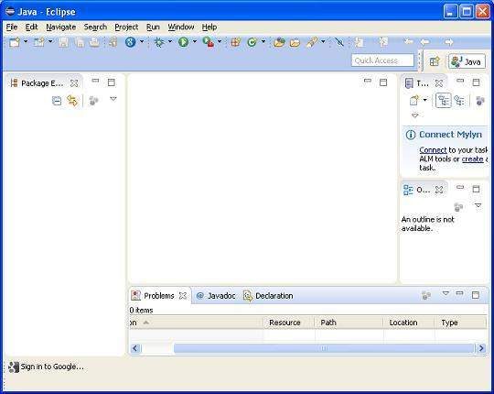

Step 4 - Setup Jersey Framework Libraries
Now if everything is fine, then you can proceed to setup Jersey framework. Following are the simple steps to download and install the framework on your machine.
- Make a choice whether you want to install Jersey on Windows, or Unix and then proceed to the next step to download .zip file for windows and .tz file for Unix.
- Download the latest version of Jersey framework binaries fromhttps://jersey.java.net/download.html.
- At the time of writing this tutorial, I downloaded jaxrs-ri-2.17.zip on my Windows machine and when you unzip the downloaded file it will give you directory structure inside E:\jaxrs-ri-2.17\jaxrs-ri as follows.
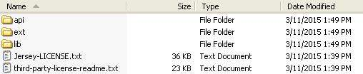
You will find all the Jersey libraries in the directories C:\jaxrs-ri-2.17\jaxrs-ri\lib and dependencies in C:\jaxrs-ri-2.17\jaxrs-ri\ext. Make sure you set your CLASSPATH variable on this directory properly otherwise you will face problem while running your application. If you are using Eclipse then it is not required to set CLASSPATH because all the setting will be done through Eclipse.

Step 5: Setup Apache Tomcat:
You can download the latest version of Tomcat fromhttp://tomcat.apache.org/. Once you downloaded the installation, unpack the binary distribution into a convenient location. For example in C:\apache-tomcat-7.0.59 on windows, or /usr/local/apache-tomcat-7.0.59 on Linux/Unix and set CATALINA_HOME environment variable pointing to the installation locations.
Tomcat can be started by executing the following commands on windows machine, or you can simply double click on startup.bat
%CATALINA_HOME%\bin\startup.bat

or

C:\apache-tomcat-7.0.59\bin\startup.bat
Tomcat can be started by executing the following commands on Unix (Solaris, Linux, etc.) machine:
$CATALINA_HOME/bin/startup.sh

or

/usr/local/apache-tomcat-7.0.59/bin/startup.sh
After a successful startup, the default web applications included with Tomcat will be available by visiting http://localhost:8080/. If everything is fine then it should display following result:
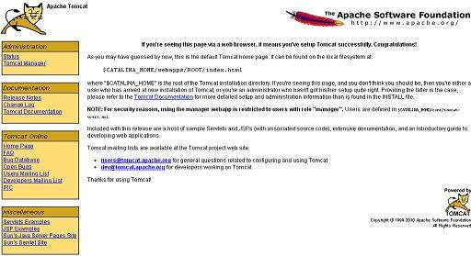
Further information about configuring and running Tomcat can be found in the documentation included here, as well as on the Tomcat web site: http://tomcat.apache.org
Tomcat can be stopped by executing the following commands on windows machine:
%CATALINA_HOME%\bin\shutdown

or

C:\apache-tomcat-7.0.59\bin\shutdown
Tomcat can be stopped by executing the following commands on Unix (Solaris, Linux, etc.) machine:
$CATALINA_HOME/bin/shutdown.sh

or

/usr/local/apache-tomcat-7.0.59/bin/shutdown.sh
Once you are done with this last step, you are ready to proceed for your first Jersey Example which you will see in the next chapter.

RESTful Web Services - First Application

Let us start writing actual RESTful web services with Jersey Framework. Before you start writing your first example using Jersey framework, you have to make sure that you have setup your Jersey environment properly as explained inRESTful Web Services - Environment Setup tutorial. I also assume that you have a little bit working knowledge with Eclipse IDE.
So let us proceed to write a simple Jersey Application which will expose a web service method to display list of users.

Step 1 - Create Java Project:
The first step is to create a Dynamic Web Project using Eclipse IDE. Follow the option File -> New -> Project and finally select Dynamic Web Project wizard from the wizard list. Now name your project as UserManagement using the wizard window as follows:
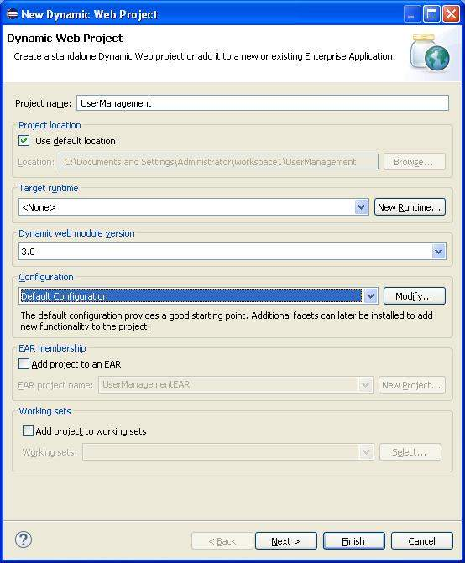
Once your project is created successfully, you will have following content in yourProject Explorer:
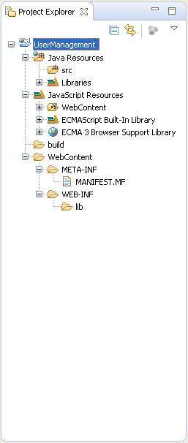

Step 2 - Add Required Libraries:
As a second step let us add Jersey Framework and its dependencies (libraries) in our project. Copy all jars from following directories of download jersey zip folder in WEB-INF/lib directory of the project.
- \jaxrs-ri-2.17\jaxrs-ri\api
- \jaxrs-ri-2.17\jaxrs-ri\ext
- \jaxrs-ri-2.17\jaxrs-ri\lib
Now, right click on your project name UserManagement and then follow the following option available in context menu: Build Path -> Configure Build Path to display the Java Build Path window.
Now use Add JARs button available under Libraries tab to add the JARs present in WEB-INF/lib directory.

Step 3 - Create Source Files:
Now let us create actual source files under the UserManagement project. First we need to create a package called com.tutorialspoint. To do this, right click on src in package explorer section and follow the option: New -> Package.
Next we will create UserService.java, User.java,UserDao.java files under the com.tutorialspoint package.
User.java
package com.tutorialspoint;

import java.io.Serializable;

import javax.xml.bind.annotation.XmlElement;
import javax.xml.bind.annotation.XmlRootElement;
@XmlRootElement(name = "user")
public class User implements Serializable {

private static final long serialVersionUID = 1L;
private int id;
private String name;
private String profession;

public User(){}

public User(int id, String name, String profession){
this.id = id;
this.name = name;
this.profession = profession;
}

public int getId() {
return id;
}

@XmlElement
public void setId(int id) {
this.id = id;
}
public String getName() {
return name;
}
@XmlElement
public void setName(String name) {
this.name = name;
}
public String getProfession() {
return profession;
}
@XmlElement
public void setProfession(String profession) {
this.profession = profession;
}
}
UserDao.java
package com.tutorialspoint;

import java.io.File;
import java.io.FileInputStream;
import java.io.FileNotFoundException;
import java.io.FileOutputStream;
import java.io.IOException;
import java.io.ObjectInputStream;
import java.io.ObjectOutputStream;
import java.util.ArrayList;
import java.util.List;

public class UserDao {
public List<User> getAllUsers(){
List<User> userList = null;
try {
File file = new File("Users.dat");
if (!file.exists()) {
User user = new User(1, "Mahesh", "Teacher");
userList = new ArrayList<User>();
userList.add(user);
saveUserList(userList);
}
else{
FileInputStream fis = new FileInputStream(file);
ObjectInputStream ois = new ObjectInputStream(fis);
userList = (List<User>) ois.readObject();
ois.close();
}
} catch (IOException e) {
e.printStackTrace();
} catch (ClassNotFoundException e) {
e.printStackTrace();
}
return userList;
}

private void saveUserList(List<User> userList){
try {
File file = new File("Users.dat");
FileOutputStream fos;

fos = new FileOutputStream(file);

ObjectOutputStream oos = new ObjectOutputStream(fos);
oos.writeObject(userList);
oos.close();
} catch (FileNotFoundException e) {
e.printStackTrace();
} catch (IOException e) {
e.printStackTrace();
}
}
}
UserService.java
package com.tutorialspoint;

import java.util.List;

import javax.ws.rs.GET;
import javax.ws.rs.Path;
import javax.ws.rs.Produces;
import javax.ws.rs.core.MediaType;

@Path("/UserService")
public class UserService {

UserDao userDao = new UserDao();

@GET
@Path("/users")
@Produces(MediaType.APPLICATION_XML)
public List<User> getUsers(){
return userDao.getAllUsers();
}
}
There are following two important points to note about the main program, UserService.java:
- First step is to specify a path for the web service using @Path annotation to UserService.
- Second step is to specify a path for the particular web service method using @Path annotation to method of UserService.

Step 4 - Create Web.xml configuration File:
You need to create a Web xml Configuration file which is an XML file and is used to specify Jersey framework servlet for our application.
web.xml
<?xml version="1.0" encoding="UTF-8"?>
<web-app xmlns:xsi="http://www.w3.org/2001/XMLSchema-instance"
xmlns="http://java.sun.com/xml/ns/javaee"
xsi:schemaLocation="http://java.sun.com/xml/ns/javaee
http://java.sun.com/xml/ns/javaee/web-app_3_0.xsd"
id="WebApp_ID" version="3.0">
<display-name>User Management</display-name>
<servlet>
<servlet-name>Jersey RESTful Application</servlet-name>
<servlet-class>org.glassfish.jersey.servlet.ServletContainer</servlet-class>
<init-param>
<param-name>jersey.config.server.provider.packages</param-name>
<param-value>com.tutorialspoint</param-value>
</init-param>
</servlet>
<servlet-mapping>
<servlet-name>Jersey RESTful Application</servlet-name>
<url-pattern>/rest/*</url-pattern>
</servlet-mapping>
</web-app>

Step 5 - Deploying the Program
Once you are done with creating source and web configuration files, you are ready for this step which is compiling and running your program. To do this, using Eclipse, export your application as a war file and deploy the same in tomcat. To create WAR file using eclipse, follow the option File -> export -> Web > War File and finally select project UserManagement and destination folder. To deploy war file in Tomcat, place the UserManagement.war in Tomcat Installation Directory > webapps directory and start the Tomcat.

Step 6 - Running the Program
We are using Postman, a Chrome extension, to test our webservices.
Make a request to UserManagement to get list of all the users. Put http://localhost:8080/UserManagement/rest/UserService/users in POSTMAN with GET request and see the below result.
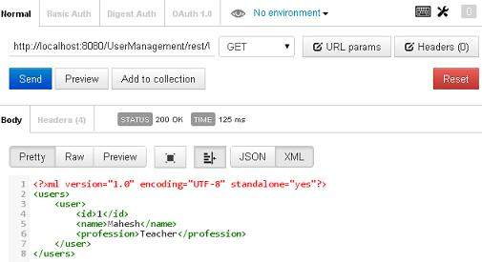
Congratulations, you have created your first RESTful Application successfully

RESTful Web Services - Resources

What is a Resource?
REST architecture treats every content as a resource. These resources can be text files, html pages, images, videos or dynamic business data. REST Server simply provides access to resources and REST client accesses and modifies the resources. Here each resource is identified by URIs/ global IDs. REST uses various representations to represent a resource where text, JSON, XML. XML and JSON are the most popular representations of resources.

Representation of Resources
A resource in REST is similar Object in Object Oriented Programming or similar to Entity in a Database. Once a resource is identified then its representation is to be decided using a standard format so that server can send the resource in above said format and client can understand the same format.
For example, in RESTful Web Services - First Application tutorial, User is a resource which is represented using following XML format:
<user>
<id>1</id>
<name>Mahesh</name>
<profession>Teacher</profession>
</user>
Same resource can be represented in JSON format as follows:
{
"id":1,
"name":"Mahesh",
"profession":"Teacher"
}

Good Resources Representation
REST does not impose any restriction on the format of a resource representation. A client can ask for JSON representation where as another client may ask for XML representation of same resource to the server and so on. It is responsibility of the REST server to pass the client the resource in the format that client understands.
Following are important points to be considered while designing a representation format of a resource in a RESTful web services.
- Understandability: Both Server and Client should be able to understand and utilize the representation format of the resource.
- Completeness: Format should be able to represent a resource completely. For example, a resource can contain another resource. Format should be able to represent simple as well as complex structures of resources.
- Linkablity: A resource can have a linkage to another resource, a format should be able to handles such situations.
However, at present most of the web services are representing resources using either XML or JSON format. There are plenty of libraries and tools available to understand, parse, and modfiy XML and JSON data.

RESTful Web Services - Messages

RESTful web services make use of HTTP protocol as a medium of communication between client and server. A client sends a message in form of a HTTP Request and server responds in form of a HTTP Response. This technique is termed as Messaging. These messages contain message data and metadata i.e. information about message itself. Let's have a look on HTTP Request and HTTP Response messages for HTTP 1.1.

HTTP Request
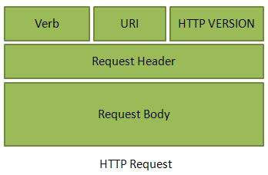
A HTTP Request has five major parts:
- Verb- Indicate HTTP methods such as GET, POST, DELETE, PUT etc.
- URI- Uniform Resource Identifier (URI) to identify the resource on server
- HTTP Version- Indicate HTTP version, for example HTTP v1.1 .
- Request Header- Contains metadata for the HTTP Request message as key-value pairs. For example, client ( or browser) type, format supported by client, format of message body, cache settings etc.
- Request Body- Message content or Resource representation.

HTTP Response
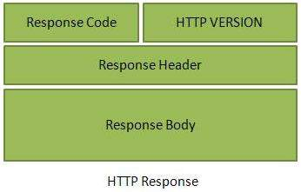
A HTTP Response has four major parts:
- Status/Response Code- Indicate Server status for the requested resource. For example 404 means resource not found and 200 means response is ok.
- HTTP Version- Indicate HTTP version, for example HTTP v1.1 .
- Response Header- Contains metadata for the HTTP Response message as key-value pairs. For example, content length, content type, response date, server type etc.
- Response Body- Response message content or Resource representation.

Example
As we have explained in RESTful Web Services - First Application tutorial, Let's put http://localhost:8080/UserManagement/rest/UserService/users in POSTMAN with GET request. If you click on Preview button residing near send button of Postman and then click on Send button, you may see the following output.
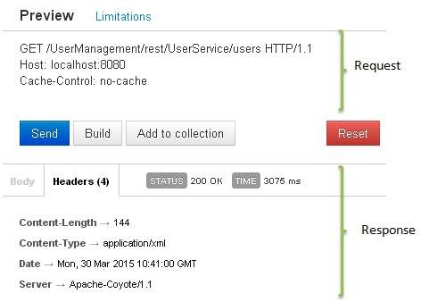
Here you can see, the browser sent a GET request and received a response body as XML.

RESTful Web Services - Addressing

Addressing refers to locating a resource or multiple resources lying on the server. It is analogous to locate a postal address of a person.
Each resource in REST architecture is identified by its URI, Uniform Resource Identifier. A URI is of following format:
<protocol>://<service-name>/<ResourceType>/<ResourceID>
Purpose of an URI is to locate a resource(s) on the server hosting the web service. Another important attribute of a request is VERB which identifies the operation to be performed on the resource. For example, in RESTful Web Services - First Application tutorial, URI ishttp://localhost:8080/UserManagement/rest/UserService/users and VERB is GET.

Constructing a standard URI
Following are important points to be considered while designing a URI:
- Use Plural Noun - Use plural noun to define resources. For example, we've used users to identify users as a resource.
- Avoid using spaces - Use underscore(_) or hyphen(-) when using a long resource name, for example, use authorized_users instead of authorized%20users.
- Use lowercase letters - Although URI is case-insensitive, it is good practice to keep url in lower case letters only.
- Maintain Backward Compatibility - As Web Service is a public service, a URI once made public should always be available. In case, URI gets updated, redirect the older URI to new URI using HTTP Status code, 300.
- Use HTTP Verb - Always use HTTP Verb like GET, PUT, and DELETE to do the operations on the resource. It is not good to use operations names in URI.

Example
Following is an example of a poor URI to fetch a user.
http://localhost:8080/UserManagement/rest/UserService/getUser/1
Following is an example of a good URI to fetch a user.
http://localhost:8080/UserManagement/rest/UserService/users/1

RESTful Web Services - Methods

s we have discussed so far that RESTful web service makes heavy uses of HTTP verbs to determine the operation to be carried out on the specified resource(s). Following table states the examples of common use of HTTP Verbs.
S.N. | HTTP Method, URI and Operation
1 | GET  http://localhost:8080/UserManagement/rest/UserService/users  Get list of users  (Read Only)
2 | GET  http://localhost:8080/UserManagement/rest/UserService/users/1  Get User of Id 1  (Read Only)
3 | PUT  http://localhost:8080/UserManagement/rest/UserService/users/2  Insert User with Id 2  (Idempotent)
4 | POST  http://localhost:8080/UserManagement/rest/UserService/users/2  Update User with Id 2  (N/A)
5 | DELETE  http://localhost:8080/UserManagement/rest/UserService/users/1  Delete User with Id 1  (Idempotent)
6 | OPTIONS  http://localhost:8080/UserManagement/rest/UserService/users  List the supported operations in web service  (Read Only)
7 | HEAD  http://localhost:8080/UserManagement/rest/UserService/users  Returns only HTTP Header, no Body.  (Read Only)
Here are important points to be considered:
- GET operations are read only and are safe.
- PUT and DELETE operations are idempotent means their result will always same no matter how many times these operations are invoked.
- PUT and POST operation are nearly same with the difference lying only in the result where PUT operation is idempotent and POST operation can cause different result.

Example
Let's update Example created in RESTful Web Services - First Applicationtutorial to create a Web service which can perform CRUD (Create, Read, Update, Delete) operations. For simplicity, we've used a file I/O to replace Database operations.
Let's update User.java, UserDao.java, and UserService.java files under the com.tutorialspoint package.
User.java
package com.tutorialspoint;

import java.io.Serializable;

import javax.xml.bind.annotation.XmlElement;
import javax.xml.bind.annotation.XmlRootElement;
@XmlRootElement(name = "user")
public class User implements Serializable {

private static final long serialVersionUID = 1L;
private int id;
private String name;
private String profession;

public User(){}

public User(int id, String name, String profession){
this.id = id;
this.name = name;
this.profession = profession;
}

public int getId() {
return id;
}
@XmlElement
public void setId(int id) {
this.id = id;
}
public String getName() {
return name;
}
@XmlElement
public void setName(String name) {
this.name = name;
}
public String getProfession() {
return profession;
}
@XmlElement
public void setProfession(String profession) {
this.profession = profession;
}

@Override
public boolean equals(Object object){
if(object == null){
return false;
}else if(!(object instanceof User)){
return false;
}else {
User user = (User)object;
if(id == user.getId()
&& name.equals(user.getName())
&& profession.equals(user.getProfession())
){
return true;
}
}
return false;
}
}
UserDao.java
package com.tutorialspoint;

import java.io.File;
import java.io.FileInputStream;
import java.io.FileNotFoundException;
import java.io.FileOutputStream;
import java.io.IOException;
import java.io.ObjectInputStream;
import java.io.ObjectOutputStream;
import java.util.ArrayList;
import java.util.List;

public class UserDao {
public List<User> getAllUsers(){
List<User> userList = null;
try {
File file = new File("Users.dat");
if (!file.exists()) {
User user = new User(1, "Mahesh", "Teacher");
userList = new ArrayList<User>();
userList.add(user);
saveUserList(userList);
}
else{
FileInputStream fis = new FileInputStream(file);
ObjectInputStream ois = new ObjectInputStream(fis);
userList = (List<User>) ois.readObject();
ois.close();
}
} catch (IOException e) {
e.printStackTrace();
} catch (ClassNotFoundException e) {
e.printStackTrace();
}
return userList;
}

public User getUser(int id){
List<User> users = getAllUsers();

for(User user: users){
if(user.getId() == id){
return user;
}
}
return null;
}

public int addUser(User pUser){
List<User> userList = getAllUsers();
boolean userExists = false;
for(User user: userList){
if(user.getId() == pUser.getId()){
userExists = true;
break;
}
}
if(!userExists){
userList.add(pUser);
saveUserList(userList);
return 1;
}
return 0;
}

public int updateUser(User pUser){
List<User> userList = getAllUsers();

for(User user: userList){
if(user.getId() == pUser.getId()){
int index = userList.indexOf(user);
userList.set(index, pUser);
saveUserList(userList);
return 1;
}
}
return 0;
}

public int deleteUser(int id){
List<User> userList = getAllUsers();

for(User user: userList){
if(user.getId() == id){
int index = userList.indexOf(user);
userList.remove(index);
saveUserList(userList);
return 1;
}
}
return 0;
}

private void saveUserList(List<User> userList){
try {
File file = new File("Users.dat");
FileOutputStream fos;

fos = new FileOutputStream(file);

ObjectOutputStream oos = new ObjectOutputStream(fos);
oos.writeObject(userList);
oos.close();
} catch (FileNotFoundException e) {
e.printStackTrace();
} catch (IOException e) {
e.printStackTrace();
}
}
}
UserService.java
package com.tutorialspoint;

import java.io.IOException;
import java.util.List;

import javax.servlet.http.HttpServletResponse;
import javax.ws.rs.Consumes;
import javax.ws.rs.DELETE;
import javax.ws.rs.FormParam;
import javax.ws.rs.GET;
import javax.ws.rs.OPTIONS;
import javax.ws.rs.POST;
import javax.ws.rs.PUT;
import javax.ws.rs.Path;
import javax.ws.rs.PathParam;
import javax.ws.rs.Produces;
import javax.ws.rs.core.Context;
import javax.ws.rs.core.MediaType;

@Path("/UserService")
public class UserService {

UserDao userDao = new UserDao();
private static final String SUCCESS_RESULT="<result>success</result>";
private static final String FAILURE_RESULT="<result>failure</result>";

@GET
@Path("/users")
@Produces(MediaType.APPLICATION_XML)
public List<User> getUsers(){
return userDao.getAllUsers();
}

@GET
@Path("/users/{userid}")
@Produces(MediaType.APPLICATION_XML)
public User getUser(@PathParam("userid") int userid){
return userDao.getUser(userid);
}

@PUT
@Path("/users")
@Produces(MediaType.APPLICATION_XML)
@Consumes(MediaType.APPLICATION_FORM_URLENCODED)
public String createUser(@FormParam("id") int id,
@FormParam("name") String name,
@FormParam("profession") String profession,
@Context HttpServletResponse servletResponse) throws IOException{
User user = new User(id, name, profession);
int result = userDao.addUser(user);
if(result == 1){
return SUCCESS_RESULT;
}
return FAILURE_RESULT;
}

@POST
@Path("/users")
@Produces(MediaType.APPLICATION_XML)
@Consumes(MediaType.APPLICATION_FORM_URLENCODED)
public String updateUser(@FormParam("id") int id,
@FormParam("name") String name,
@FormParam("profession") String profession,
@Context HttpServletResponse servletResponse) throws IOException{
User user = new User(id, name, profession);
int result = userDao.updateUser(user);
if(result == 1){
return SUCCESS_RESULT;
}
return FAILURE_RESULT;
}

@DELETE
@Path("/users/{userid}")
@Produces(MediaType.APPLICATION_XML)
public String deleteUser(@PathParam("userid") int userid){
int result = userDao.deleteUser(userid);
if(result == 1){
return SUCCESS_RESULT;
}
return FAILURE_RESULT;
}

@OPTIONS
@Path("/users")
@Produces(MediaType.APPLICATION_XML)
public String getSupportedOperations(){
return "<operations>GET, PUT, POST, DELETE</operations>";
}
}
Now using Eclipse, export your application as a war file and deploy the same in tomcat. To create WAR file using eclipse, follow the option File -> export -> Web > War File and finally select project UserManagement and destination folder. To deploy war file in Tomcat, place the UserManagement.war in Tomcat Installation Directory > webapps directory and start the Tomcat.

Testing the Web Service
Jersey provides APIs to create a Web Service Client to test web services. We've created a sample test class WebServiceTester.java under the com.tutorialspoint package in the same project.
WebServiceTester.java
package com.tutorialspoint;

import java.util.List;

import javax.ws.rs.client.Client;
import javax.ws.rs.client.ClientBuilder;
import javax.ws.rs.client.Entity;
import javax.ws.rs.core.Form;
import javax.ws.rs.core.GenericType;
import javax.ws.rs.core.MediaType;

public class WebServiceTester {

private Client client;
private String REST_SERVICE_URL = "http://localhost:8080/UserManagement/rest/UserService/users";
private static final String SUCCESS_RESULT="<result>success</result>";
private static final String PASS = "pass";
private static final String FAIL = "fail";

private void init(){
this.client = ClientBuilder.newClient();
}

public static void main(String[] args){
WebServiceTester tester = new WebServiceTester();
//initialize the tester
tester.init();
//test get all users Web Service Method
tester.testGetAllUsers();
//test get user Web Service Method
tester.testGetUser();
//test update user Web Service Method
tester.testUpdateUser();
//test add user Web Service Method
tester.testAddUser();
//test delete user Web Service Method
tester.testDeleteUser();
}
//Test: Get list of all users
//Test: Check if list is not empty
private void testGetAllUsers(){
GenericType<List<User>> list = new GenericType<List<User>>() {};
List<User> users = client
.target(REST_SERVICE_URL)
.request(MediaType.APPLICATION_XML)
.get(list);
String result = PASS;
if(users.isEmpty()){
result = FAIL;
}
System.out.println("Test case name: testGetAllUsers, Result: " + result );
}
//Test: Get User of id 1
//Test: Check if user is same as sample user
private void testGetUser(){
User sampleUser = new User();
sampleUser.setId(1);

User user = client
.target(REST_SERVICE_URL)
.path("/{userid}")
.resolveTemplate("userid", 1)
.request(MediaType.APPLICATION_XML)
.get(User.class);
String result = FAIL;
if(sampleUser != null && sampleUser.getId() == user.getId()){
result = PASS;
}
System.out.println("Test case name: testGetUser, Result: " + result );
}
//Test: Update User of id 1
//Test: Check if result is success XML.
private void testUpdateUser(){
Form form = new Form();
form.param("id", "1");
form.param("name", "suresh");
form.param("profession", "clerk");

String callResult = client
.target(REST_SERVICE_URL)
.request(MediaType.APPLICATION_XML)
.post(Entity.entity(form,
MediaType.APPLICATION_FORM_URLENCODED_TYPE),
String.class);
String result = PASS;
if(!SUCCESS_RESULT.equals(callResult)){
result = FAIL;
}

System.out.println("Test case name: testUpdateUser, Result: " + result );
}
//Test: Add User of id 2
//Test: Check if result is success XML.
private void testAddUser(){
Form form = new Form();
form.param("id", "2");
form.param("name", "naresh");
form.param("profession", "clerk");

String callResult = client
.target(REST_SERVICE_URL)
.request(MediaType.APPLICATION_XML)
.put(Entity.entity(form,
MediaType.APPLICATION_FORM_URLENCODED_TYPE),
String.class);

String result = PASS;
if(!SUCCESS_RESULT.equals(callResult)){
result = FAIL;
}

System.out.println("Test case name: testAddUser, Result: " + result );
}
//Test: Delete User of id 2
//Test: Check if result is success XML.
private void testDeleteUser(){
String callResult = client
.target(REST_SERVICE_URL)
.path("/{userid}")
.resolveTemplate("userid", 2)
.request(MediaType.APPLICATION_XML)
.delete(String.class);

String result = PASS;
if(!SUCCESS_RESULT.equals(callResult)){
result = FAIL;
}

System.out.println("Test case name: testDeleteUser, Result: " + result );
}
}
Now run the tester using Eclipse. Right click on the file, and follow the optionRun as -> Java Application. You'll see the following result in Eclipse console:
Test case name: testGetAllUsers, Result: pass
Test case name: testGetUser, Result: pass
Test case name: testUpdateUser, Result: pass
Test case name: testAddUser, Result: pass
Test case name: testDeleteUser, Result: pass

RESTful Web Services - Statelessness

As per REST architecture, a RESTful web service should not keep a client state on server. This restriction is called statelessness. It is responsibility of the client to pass its context to server and then server can store this context to process client's further request. For example, session maintained by server is identified by session identifier passed by the client.
RESTful Web services should adhere to this restriction. We've seen in RESTful Web Services - Methods tutorial, that Web service methods are not storing any information from the client they are invoked from.
Consider the following URL:
http://localhost:8080/UserManagement/rest/UserService/users/1
If you hit the above url using browser, using java based client or using postman, result will always be the User XML whose Id is 1 because server does not store any information about the client.
<user>
<id>1</id>
<name>mahesh</name>
<profession>1</profession>
</user>

Advantages of Statelessness
Following are the benefits of statelessness in RESTful web services
- Web services can treat each method request independently.
- Web services need not to maintain client's previous interactions. It simplifies application design.
- As HTTP is itself a statelessness protocol, RESTful Web services work seamlessly with HTTP protocol.

Disadvantages of Statelessness
Following are the disadvantages of statelessness in RESTful web services
- Web services need to get extra information in each request and then interpret to get the client's state in case client interactions are to be taken care of.

RESTful Web Services - Caching

Caching refers to storing server response in client itself so that a client needs not to make server request for same resource again and again. A server response should have information about how a caching is to be done so that a client caches response for a period of time or never caches the server response.
Following are the headers which a server response can have in order to configure a client's caching:
S.N. | Header & Description
1 | Date  Date and Time of the resource when it was created.
2 | Last Modified  Date and Time of the resource when it was last modified.
3 | Cache-Control  Primary header to control caching.
4 | Expires  Expiration date and time of caching
5 | Age  Duration in seconds from when resource was fetched from the server.

Cache-Control Header
Following are the details of Cache-Control header
S. N. | Directive & Description
1 | Public  Indicates that resource is cachable by any component.
2 | Private  Indicates that resource is cachable by only client and server, no intermediary can cache the resource.
3 | no-cache/no-store  Indicates that resource is not cachable
4 | max-age  Indicates the caching is valid up to max-age in seconds. After this, client has to make another request.
5 | must-revalidate  Indication to server to revalidate resource if max-age has passed.

Best Practices
- Always keep static contents like images, css, JavaScript cacheable, with expiration date of 2 to 3 days.
- Never keep expiry date too high.
- Dynamic contents should be cached for few hours only.
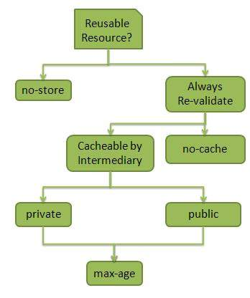

RESTful Web Services - Security

As RESTful web services work with HTTP URLs Paths so it is very important to safeguard a RESTful web service in the same manner as a website is be secured. Following are the best practices to be followed while designing a RESTful web service.
- Validation - Validate all inputs on the server. Protect your server against SQL or NoSQL injection attacks.
- Session based authentication - Use session based authentication to authenticate a user whenever a request is made to a Web Service method.
- No sensitive data in URL - Never use username, password or session token in URL , these values should be passed to Web Service via POST method.
- Restriction on Method execution - Allow restricted use of methods like GET, POST, DELETE. GET method should not be able to delete data.
- Validate Malformed XML/JSON - Check for well formed input passed to a web service method.
- Throw generic Error Messages - A web service method should use HTTP error messages like 403 to show access forbidden etc.

HTTP Code:
S.N. | HTTP Code & Description
1 | 200  OK, shows success.
2 | 201  CREATED, when a resource is successful created using POST or PUT request. Return link to newly created resource using location header.
3 | 204  NO CONTENT, when response body is empty for example, a DELETE request.
4 | 304  NOT MODIFIED, used to reduce network bandwidth usage in case of conditional GET requests. Response body should be empty. Headers should have date, location etc.
5 | 400  BAD REQUEST, states that invalid input is provided e.g. validation error, missing data.
6 | 401  UNAUTHORIZED, states that user is using invalid or wrong authentication token.
7 | 403  FORBIDDEN, states that user is not having access to method being used for example, delete access without admin rights.
8 | 404  NOT FOUND, states that method is not available.
9 | 409  CONFLICT, states conflict situation while executing the method for example, adding duplicate entry.
10 | 500  INTERNAL SERVER ERROR, states that server has thrown some exception while executing the method.

RESTful Web Services - Java (JAX-RS)

JAX-RS stands for JAVA API for RESTful Web Services. JAX-RS is a JAVA based programming language API and specification to provide support for created RESTful Webservices. Its 2.0 version was released in 24 May 2013. JAX-RS makes heavy use of annotations available from Java SE 5 to simplify development of JAVA based web services creation and deployment. It also provides supports for creating clients for RESTful web services.

Specification
Following are the commonly used annotations to map a resource as a web service resource.
S.N. | Annotation & Description
1 | @Path  Relative path of the resource class/method.
2 | @GET  HTTP Get request, used to fetch resource.
3 | @PUT  HTTP PUT request, used to create resource.
4 | @POST  HTTP POST request, used to create/update resource.
5 | @DELETE  HTTP DELETE request, used to delete resource.
6 | @HEAD  HTTP HEAD request, used to get status of method availability.
7 | @Produces  States the HTTP Response generated by web service, for example APPLICATION/XML, TEXT/HTML, APPLICATION/JSON etc.
8 | @Consumes  States the HTTP Request type, for example application/x-www-form-urlencoded to accept form data in HTTP body during POST request.
9 | @PathParam  Binds the parameter passed to method to a value in path.
10 | @QueryParam  Binds the parameter passed to method to a query parameter in path.
11 | @MatrixParam  Binds the parameter passed to method to a HTTP matrix parameter in path.
12 | @HeaderParam  Binds the parameter passed to method to a HTTP header.
13 | @CookieParam  Binds the parameter passed to method to a Cookie.
14 | @FormParam  Binds the parameter passed to method to a form value.
15 | @DefaultValue  Assigns a default value to a parameter passed to method.
16 | @Context  Context of the resource for example HTTPRequest as a context.

